***NAME : Himanshu Dixit***

***ENROLL NO. : B64178***

***BATCH : B10***

***SOFTWARE DEVELOPMENT FUNDAMENTAL LAB-I(15B17CI171) Assignment Sheet (WEEK-7 PHASE-2)***

***Lab B***

**1.** WAP that inputs two numbers from user and function that finds if first number is multiple of another or not.

***Solution:***

#include<stdio.h>

int multiple(int a,int b)

{

if(a%b==0)

printf("%d is a multiple of %d",a,b);

else

printf("%d is a not a multiple of %d",a,b);

}

int main()

{

int a,b;

scanf("%d%d",&a,&b);

multiple(a,b);

return 0;

}

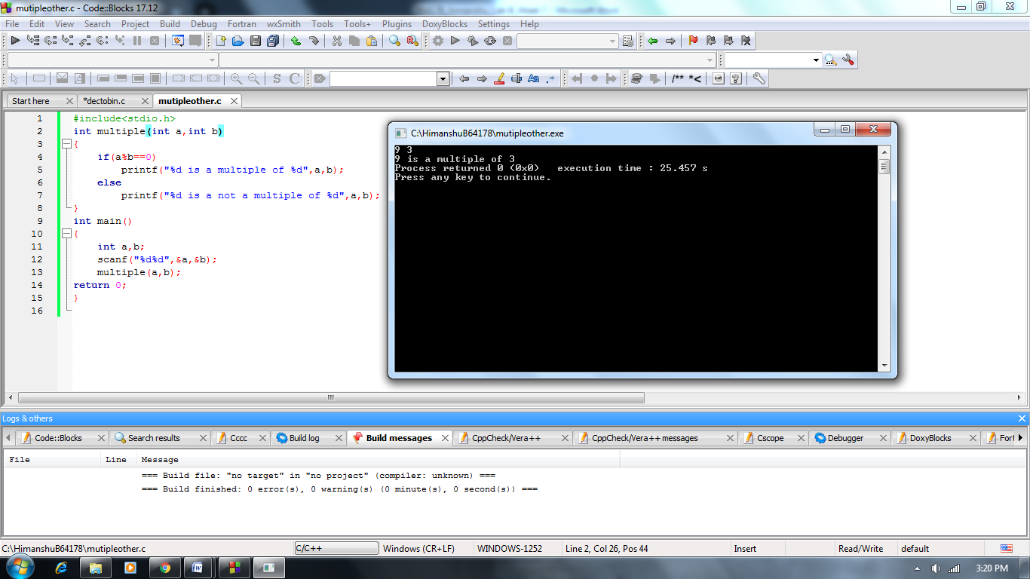

**2.** Write a sample program that uses function to find the maximum value in an array of integers.

***Solution:***

#include<stdio.h>

int max(int a[100], int n)

{

int m=a[0];

for(int i=0;i<n;i++)

{

if(m<a[i])

m=a[i];

}

printf("max value is %d",m);

}

int main()

{

int a[100],n;

scanf("%d",&n);

for(int i=0;i<n;i++)

scanf("%d",&a[i]);

max(a,n);

return 0;

}

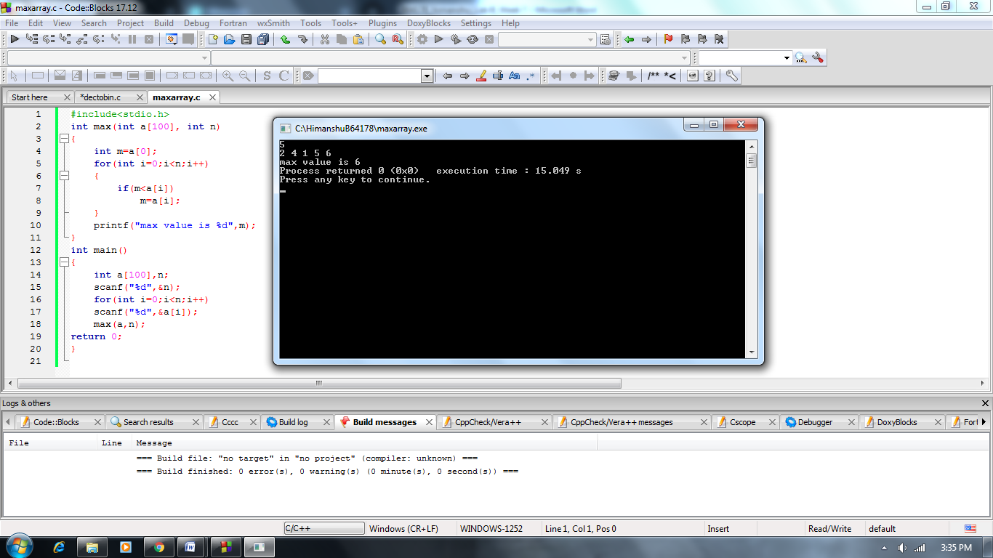

**3.** WAP that reads a string and a character. Using functions find if the character is present in the string or not.

***Solution:***

#include<stdio.h>

void chstr(char a[100], char ch)

{

int n=0;

for(int i=0;a[i]!='\0';i++)

{

if(a[i]==ch)

n=1;

}

if(n==1)

printf("character is present.");

else

printf("character is not present.");

}

int main()

{

char a[100],ch;

scanf("%c",&ch);

scanf("%s",a);

chstr(a,ch);

return 0;

}

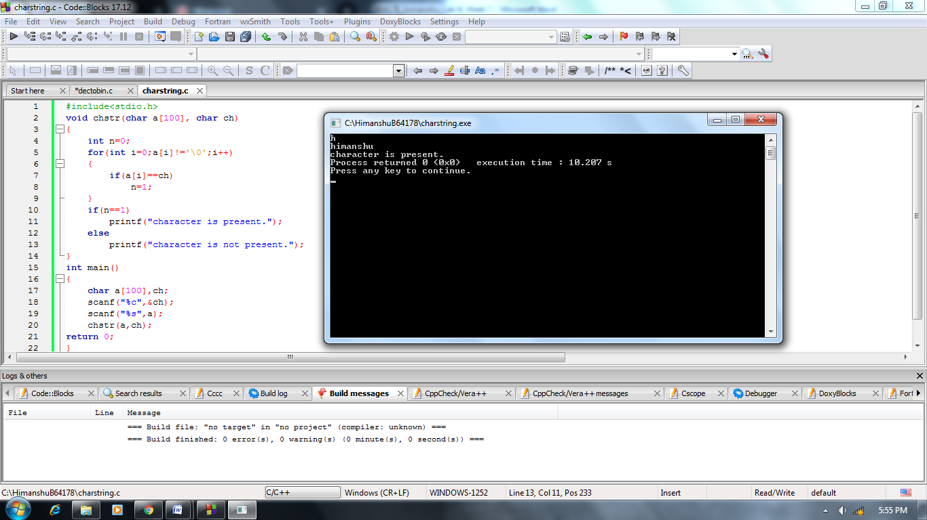

**4.** WAP using function that will return the length of a character string. You are not allowed to use the strlen C library function.

***Solution:***

#include<stdio.h>

void slen(char a[100])

{

int l=0;

for(int i=0;a[i]!='\0';i++)

{

l++;

}

printf("length of string is %d ",l);

}

int main()

{

char a[100];

scanf("%s",a);

slen(a);

return 0;

}

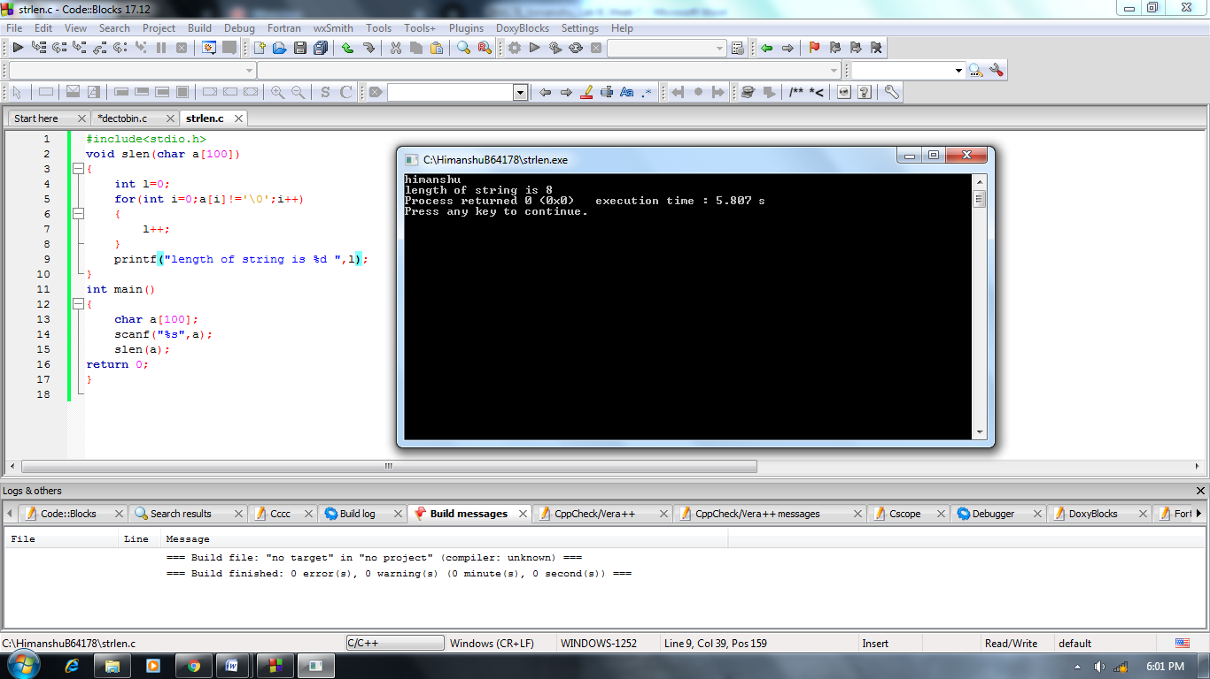

**5.** WAP using function to find factorial of a number.

***Solution:***

#include<stdio.h>

void fact(int num)

{

int f=1;

for(int i=1;i<=num;i++)

{

f=f*i;

}

printf("factorial of number is %d ",f);

}

int main()

{

int n;

scanf("%d",&n);

fact(n);

return 0;

}

